Ideation Phase
Define the Problem Statements

Date | 20 February 2026
Team ID | LTVIP2026TMIDS47668
Project Name | Rising Waters: A Machine Learning Approach to Flood Prediction
Maximum Marks | 2 Marks

Customer Problem Statement: Flood Prediction
Government agencies, urban planners, and disaster management teams are increasingly dependent on advanced forecasting technologies to protect infrastructure and save lives in the face of climate change. Flood prediction is a critical part of this transition, but the onset and severity of rising waters are highly variable due to complex environmental factors and shifting weather patterns.
Empathy Statement: Rising Waters
City officials and residents feel vulnerable and anxious when they cannot rely on traditional flood forecasts. They want confidence that their disaster preparedness strategies will effectively protect lives and property, and they need tools that make flood risk management as precise and actionable as modern weather tracking.
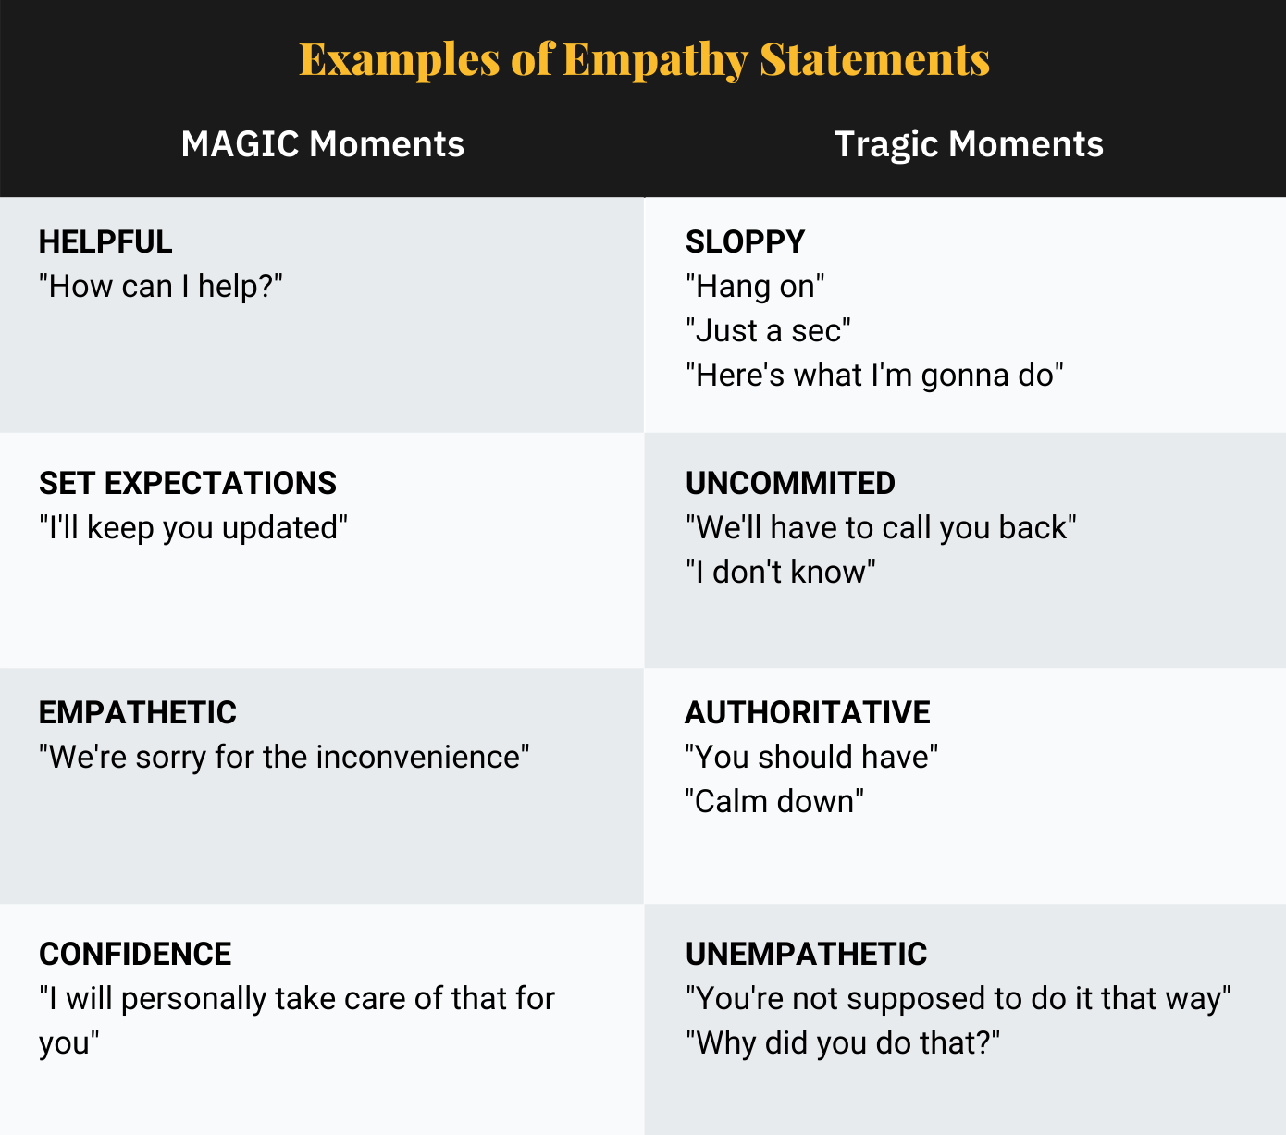
Reference: https://miro.com/templates/customer-problem-statement/

Example:

Problem Statement (PS) | I am (Customer) | I’m trying to | But | Because | Which makes me feel
PS-1
PS-2

